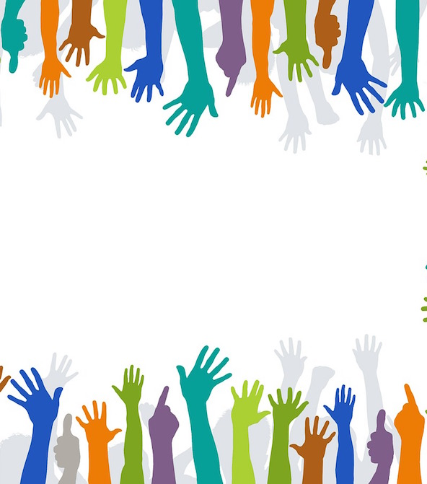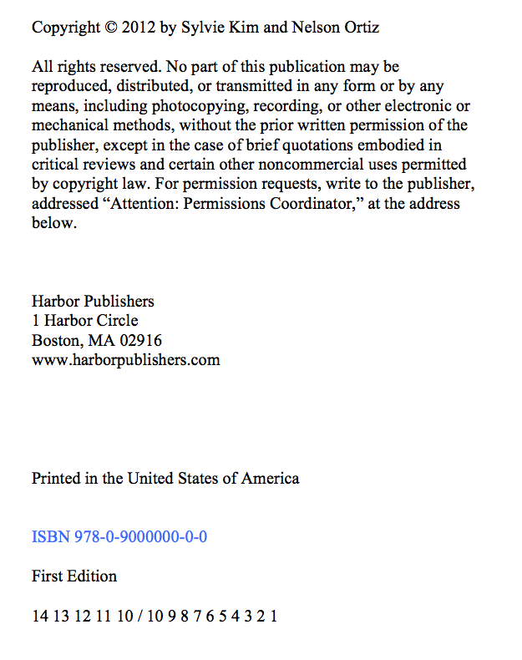

Volunteering:

Be the Best You Can Be

Sylvie Kim and Nelson Ortiz

Harbor Publishers

Scroll down to view the second source

So You Want to Volunteer?

*By*

Seleste Harding

Journal of Public Assistance

*Figure 1. The volunteerism cycle*

*Figure 2. Ages and stages of volunteering*

We have all heard general statements about the benefits of volunteering. You meet new people, gain confidence in yourself, develop new skills, are a part of a community, have fun, and gain the satisfaction of “making a difference.” All of these describe benefits to the volunteer, but what is the real impact of volunteering? Who does it affect and how? When does

*This article uses data from several studies conducted over a multi-year period to explore the impact of volunteerism both on those who volunteer, and on those who are impacted by the services provide by volunteers.*

*Journal of Public Assistance* 18

December, 2000

Volume 24, Issue 16